**Coding notes**

Overall, this homework assignment was quite challenging as there were many instances where I had to research how to solve for what was being requested. Some concepts used were not used nor discussed during class. The activities required one to take various aspects of what has been learned to date – specifically creating variables to hold values at a later step. The TRY statement was a new concept with this assignment, and I would not be surprised if use of this and appending of data could have been a bit more efficiently. However, when a solution works it is best to leave it. I realize in the WeatherPy notebook when calling for random cities to research weather conditions, I also printed the target Url. I know that this could be easily updated, but I wanted to be cautious on the number of calls being conducted to the API. The more practice I get on creating and adjusting dataframes, the more comfortable and confident I feel. Even though there were no cities where humidity was greater than 100, I still went through the data clean up process (for practice purposes).

In the WeatherPy exercise, we were asked to save plots as .png files. As you can see with the code and screen print below, these were created. However, when I try to open these they all appear to be blank. So copies of plots created are taken from the Jupyter notebook.

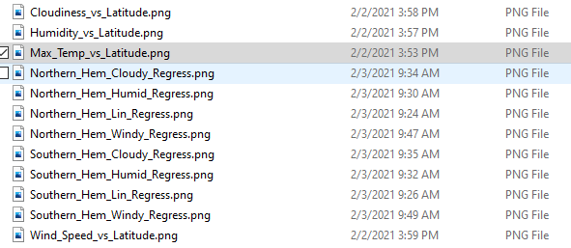

Similar to the Matplotlib homework assignment, I again experience problems where the line regression charts did not show the y equation although the same code was utilized.

** Also note that I misspelled temperature in my code and due to concerns with API calls, I opted not to correct this.

**Plot Review**

The City Latitude vs. Maximum Tempurature scatter plot below shows all random cities selected and their corresponding temperatures and latitude. This provides evidence that temperatures are normally higher the closer that city is to the equator.

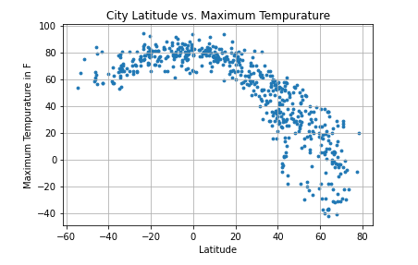

The City Latitude vs. Humidity scatter plot below shows no correlation of humidity as you get closer to the equator. Funny observation – just in time for Valentine’s Day this chart looks to have plotted like a heart.

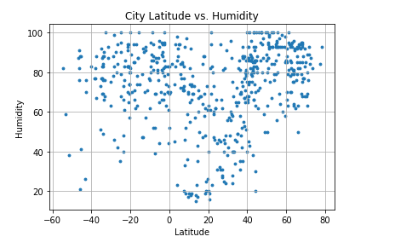

The City Latitude vs. Cloudiness scatter plot below shows no correlation of cloudiness as you get closer to the equator.

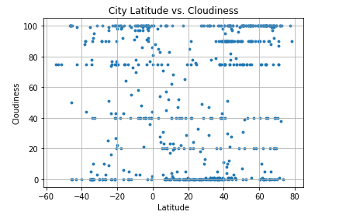

The City Latitude vs. Wind Speed scatter plot below shows no correlation of increased wind speeds as you get closer to the equator.

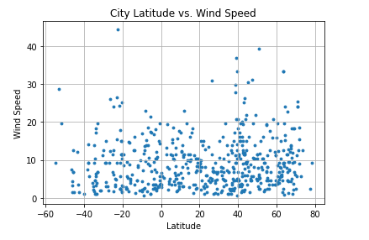

WeatherPy – Line Regression

Below are some side-by-side comparisons of various weather components of Northern vs Southern hemisphere cities.

**Northern Hemisphere**

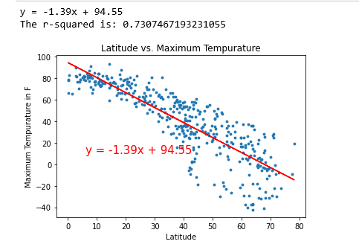

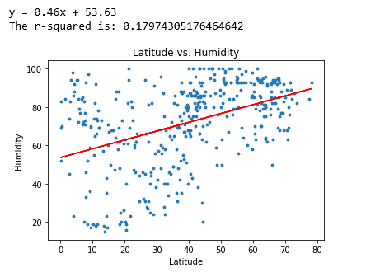

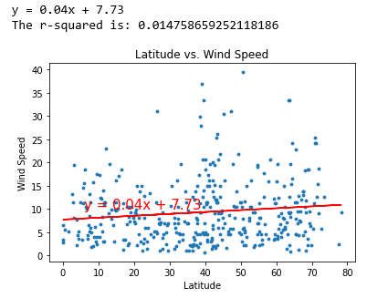

**Southern Hemisphere**

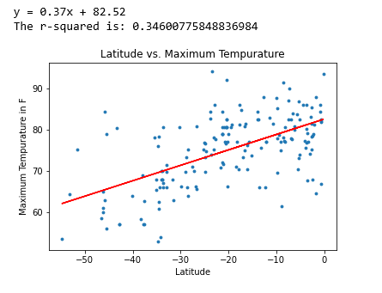

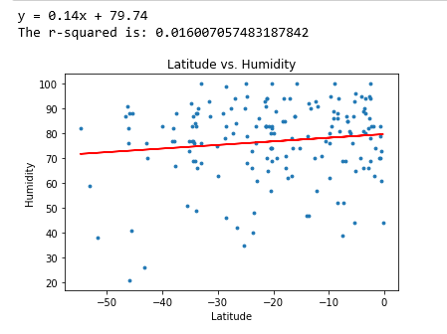

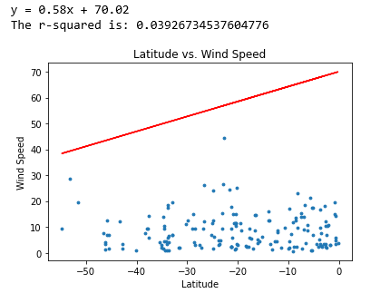

**Northern Hemisphere**

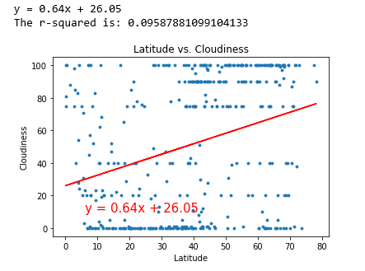 **Southern Hemisphere**

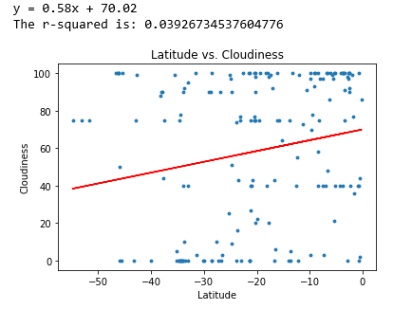

**VacationPy**

As I brought in my csv from the WeatherPy assignment, I started running into coding errors with the data. Therefore, I evaluated the data types and made the necessary adjustments. Additionally, I also had to remove the index column created with the csv file.

Once my data was cleans, I modified existing code as needed to find hotels around cities with ideal weather conditions, which was temperatures greater than or equal to 70 degrees F, humidity was less than 50% and with minimal clouds. Approximately 23 matches were identified. These cities were then searched against the Google Places API to find nearby hotels. 7 of the 23 locations had no hotel results and were removed from the final dataframe. With code provided the heatmap below was generated.

Personally, I plan to research the Manzanillo location for future vacation travel.

